**Wall Street giant, Anthony Scaramucci and Asia’s #1 Fund, Blockchain Founders Fund, fill the Strategic Round at TDMM**

**to kick off the next round at 75 Million USD.**

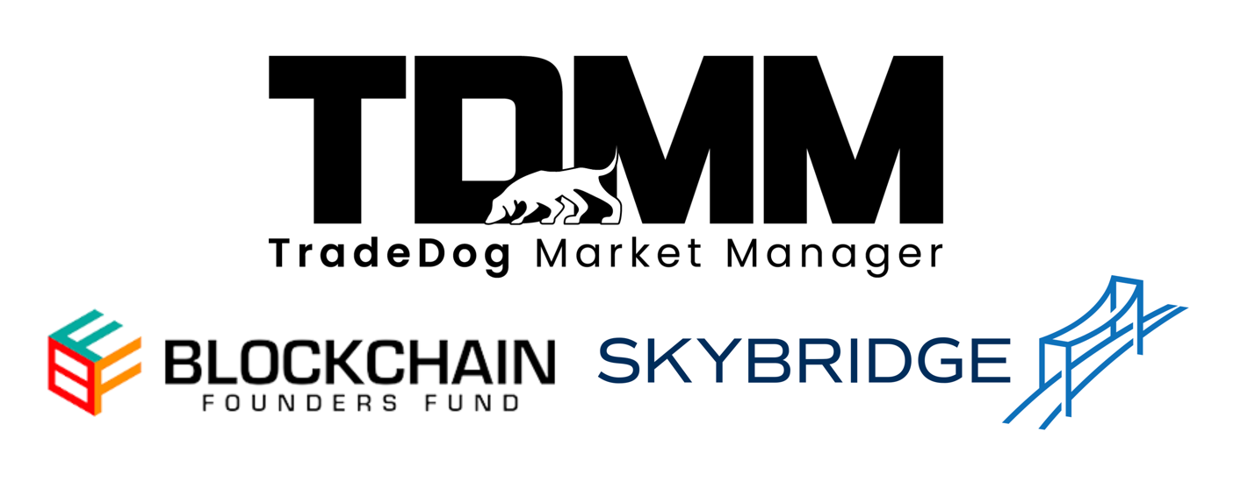

**Delhi, India – June 26, 2024** – TradeDog Market Management (TDMM), a global leader in crypto trading with over $10 billion in trading volume, has secured investment from prominent venture capital firm Blockchain Founders Fund (BFF) and renowned Wall Street investor Anthony Scaramucci. This joint investment signifies the collective confidence in TDMM's innovative approach to crypto trading and its potential to become a major player in the global crypto space.

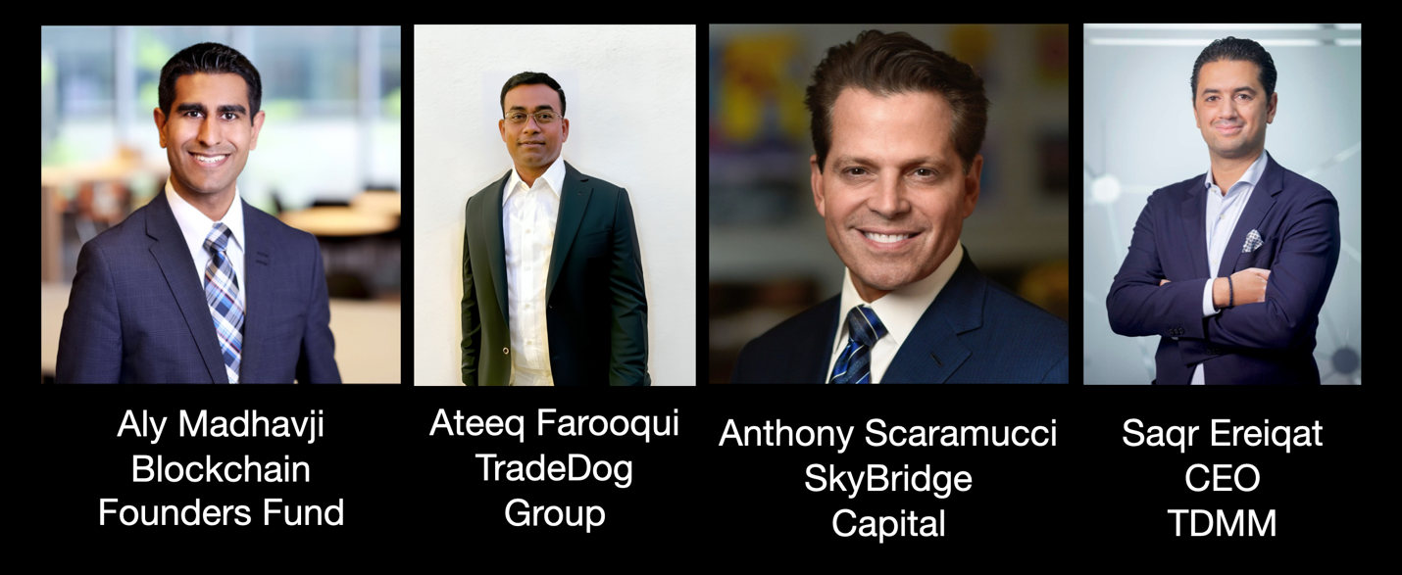

[TradeDog Market Manager](https://tdmm.io/) (TDMM) announces its seed round fundraiser after successfully closing a strategic round for select VCs with a large Token portfolio led by Blockchain Founders Fund (BFF) and Anthony Scaramucci, [SkyBridge Capital](https://www.skybridge.com/).

**Key Highlights**

● TDMM’s pioneering institutional-grade crypto trading solutions now have a powerful validation for institutional investors and their existing clients.

● This strategic investment fuels TDMM's ambitious growth and investment plans. The capital influx will be instrumental in securing strategic investments in Token Startups and Enterprises.

● The partnership with BFF and Mr Scaramucci grants TDMM access to invaluable expertise and a vast network within the blockchain industry and traditional finance.

TDMM is a leading crypto market-making solutions provider, offering comprehensive yield and exit management services to institutional clients worldwide and liquidity, treasury, and inventory management to token companies. It is integrated with 60+ CEXs and DEXs and manages 100+ assets across 300+ pairs.

"At TDMM, we see our partnership not just as an investment, but as a shared vision for the future of crypto trading," said Saqr Ereiqat, CEO of TDMM. "We are committed to redefining Token Market Making (MM) by engaging transparently with our clients, providing sophisticated financial services, and the execution, a token needs to thrive and succeed. Together, we aim to revolutionize the landscape of MM and set the golden standard of collaboration and mutual success."

Ateeq Farooqui, Head of Trading and Co-Founder of TradeDog Group responded, “Gaurav and I started aggressive crypto trading alongside our mining operations in 2015 to mitigate our risk around the mined Coins. We’ve come a long way from there and we are working towards onboarding large institutional capital through our extensive suite of services.”

BFF is a prominent venture capital powerhouse that invests globally in top-tier, early-stage blockchain startups at the seed and pre-seed stages. The fund leverages its extensive industry knowledge and network to empower these companies and drive innovation within the blockchain space. BFF extends beyond traditional financial backing and cultivates a collaborative partnership with its portfolio companies, providing access to a curated network of leading figures in cryptocurrency and traditional finance sectors.

"[TDMM](https://tdmm.io/) is at the forefront of revolutionizing crypto trading with their pioneering solutions. Our investment in TDMM is a testament to our belief in their vision and capabilities. We are excited to support TDMM as they set new industry standards and drive the future of institutional engagement in the digital asset market." - Aly Madhavji, Managing Partner, Blockchain Founders Fund.

[Skybridge Capital](https://www.skybridge.com/) is a Multi-Billion Dollar Alternative Investment Fund founded by Anthony Scaramucci, an Investor at Blackrock’s Bitcoin ETF, iShares. He also founded SALT, one of the world’s largest conferences for Fund Allocators and managers. ‘’The Mooch’ is a seasoned investor and astute market observer with a blockchain vision. He brings a wealth of experience and a vast network crucial in capitalizing on emerging opportunities with the Institutional Financial world looking to invest in Web3.

As digital assets reshape the global financial markets, TDMM embarks on this new chapter, facilitated by Anthony Scaramucci’s acumen and BFF’s unparalleled experience, to scale new heights and position itself for continued success in the digital asset sector.

**About TDMM**

TDMM is an established crypto trading firm with solid traction and a thriving ecosystem from TradeDog Group. The company builds scalable liquidity on digital assets, generating over $5 billion in trading volume. With a team of 30+ professionals across 20+ countries, TDMM serves 40+ clients across Defi, GameFi, and Infrastructure.

**About Blockchain Founders Fund (BFF)**

[Blockchain Founders Fund](https://blockchainff.com/) is a leading early-stage (seed and pre-seed) Web3 Venture Capital fund that invests in top-tier founders globally. Its backers include a strategic mix of the leading crypto and traditional finance firms.

BFF invests in highly promising startups, focusing on go-to-market strategies and taking a hands-on approach to driving value. BFF helps curate strategic partnerships, hire talent, accelerate growth, and ensure portfolio founders are well-capitalized. Their team comprises builders and operators who have scaled many leading Blockchain startups and are on a mission to support all-star teams shaping the Web3 industry.

**About Anthony Scaramucci**

Anthony Scaramucci, a luminary in investment circles, brings a wealth of experience in traditional finance and the burgeoning blockchain sector. Anthony is a prominent figure in the investment community and is mainly known for his strategic blockchain investments. His firm is at the forefront of incorporating blockchain technology into traditional finance, managing a diverse portfolio of digital assets.